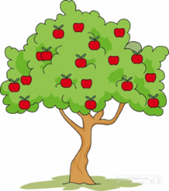 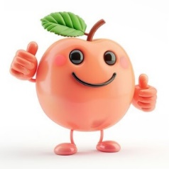

Our Spring Term enquiry focus throughout school is SCIENCE. Our Big Question is: Do animals and humans need the same things to stay happy and healthy? Pips may experience some of this learning throughout the term, depending on the sessions they attend.

Pips focussed learning this half term:

|  |  |  |  |  |
| --- | --- | --- | --- | --- |
| Phonics | Literacy | Maths | P.E | Wild Wednesday |
| Phase 1 phonics – listen and become more aware of the sounds around us. | Listen to and talk about stories.  Play rhyming games.  Practise forming letters and writing our name. | Counting and counting songs. | This will be on a Tuesday afternoon. Please come to school wearing P.E kit (Navy blue tracksuit or leggings, white t-shirt, trainers).  Dance. | This will take place every Wednesday morning. Please send waterproof trousers, coat and welly boots in a named bag to stay at school if your child attends school on a Wednesday. |