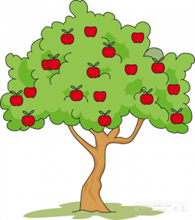

Our Spring Term enquiry focus will be a SCIENCE one:

Big Question: Do animals and humans need the same things to stay happy and healthy?

Other Subjects:

|  |  |
| --- | --- |
| English | Our key texts will be:  All Kinds of People, Oliver’s Vegetables, Oliver’s Fruit Salad, I Wish I’d Looked After Me Teeth, The Selfish Crocodile, The Little Red Hen, The Very Hungry Caterpillar, and Handa’s Surprise.  We will be writing labels, sentences, captions and instructions, acrostic poems, speech bubbles, and letters. |
| Maths | We follow the White Rose Maths Scheme and Mastering Numbers. This term’s units are Alive in 5, Mass and Capacity, Growing 6, 7, 8, Length, Height and Time, Building 9 and 10, Explore 3d shapes. |
| R.E. | Special Times and Places; Christianity and celebrations. |
| Science | Learn about the season of Spring. Learn about animals including humans; learn about our teeth and our senses. Learn about the life cycle of a butterfly and explore habitats of different animals. |
| RSHE | This term’s units are Keeping Safe and Rights and Respect. |
| P.E. | A (agility), B (balance), C (co-ordination) Dance and invasion games. |
| Understanding the World | Use 4 compass directions and simple maps in orienteering games.  Create a simple map of where to find minibeasts in our school grounds. |
| Expressive Arts and Design, Creating with Materials | **Sketching** pictures of our fruit salad, pictures of animals.  **Joins** make a moving skeleton.  **Painting** symmetrical butterflies.  **Crafting** with play dough.  **Cutting** paper to makepaper chains, character head bands. |
| Music | Follow our Mr Quaver programme. |