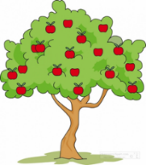 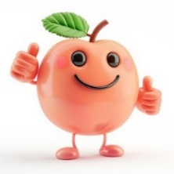

Our Summer Term enquiry focus throughout school is GEOGRAPHY.

Our Big Question is: **What is life like in India?**

Pips may experience some of this learning throughout the term, depending on the sessions they attend. Pips focussed learning this term:

|  |  |  |  |  |
| --- | --- | --- | --- | --- |
| Phonics | Literacy | Maths | P.E | Wild Wednesday |
| Phase 1 phonics – oral blending and segmenting. | Sequence stories using pictures. Look at pictures of Indian animals (in fiction and non-fiction books) and describe them. Listen to stories and join in with repeated refrains, starting to be able to re-tell them. Develop our pencil grip and write our names. | Counting (take and give 1, 2, 3, show me 5, stop at 1, 2, 3, 4, 5). Shape, Space and Measure (match, talk, push and pull, and start to puzzle). Subitising (talk about dots, make games and actions). Comparing (compare and sort collections, match sort and compare). Pattern (lead on own repeats, making patterns together and my own pattern). | This will be on a Monday afternoon. Please come to school wearing P.E kit (Navy blue tracksuit or leggings, white t-shirt, trainers).  Ball skills and sports day practise. | This will take place every Wednesday afternoon. Please send waterproof trousers, coat and welly boots in a named bag to stay at school if your child attends school on a Wednesday. |