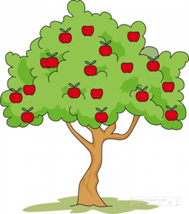

Our Summer Term enquiry focus will be a GEOGRAPHY – UNDERSTANDING THE WORLD one:

Big Question: What is life like in India?

Other Subjects:

|  |  |
| --- | --- |
| English | Our key texts will be:  The Tiger Who Came to Tea, Non-fiction book about tigers, Chapati Moon, The Runaway Pancake, Dear Zoo, Cinderella, Elmer stories.  We will be writing captions, fact files, invitations and recounts. We will be building our writing stamina to write several sentences. |
| Maths | We continue to follow the White Rose Maths Scheme and Mastering Numbers. This term’s units are numbers to 20 and beyond, addition and subtraction, manipulating, composing and decomposing shapes, sharing and grouping, visualising, building and mapping, and making connections. |
| R.E. | Learning about the Hindu religion in India and comparing it to Christianity. Learning about special places in different religions and what makes them special. |
| Science | Learn about the season of Summer. Explore how objects move in water, thinking about forces. Learn about Indian animals and their habitats. Use our senses as we try some Indian food. |
| RSHE | This term’s units are Being My Best and Growing and Changing. |
| P.E. | A (agility), B (balance), C (co-ordination) ball skills and sports day practise. |
| Understanding the World | Draw information from a simple map. Recognise some similarities and differences between life in this country and life in other countries. |
| Expressive Arts and Design, Creating with Materials | **Collage** an Indian flag and tiger face using different materials.  **Printing** with fruit/vegetables.  **Painting** a tiger.  **Textiles** make a sock puppet.  **Food** make a chapati.  **Craft** box modelling, concertina snakes, Rangoli patterns, milk bottle elephants. |
| Music | Follow our Mr Quaver programme. |