TEACHERS: Mrs Smith will teach Cherry Class on Mondays, Tuesdays & Wednesdays. Mrs Clark will teach the class every Thursday & Friday.

The Monkey Book
The Monkey Book is a home-school record for your child. The work for the week is stuck on the right-hand side page. Important messages also appear in this section. Please encourage your child to talk about their day & what they have enjoyed at school. Speak to us if you have any queries or concerns. Please send your child to school with their Monkey Book every day.
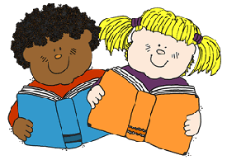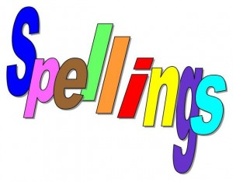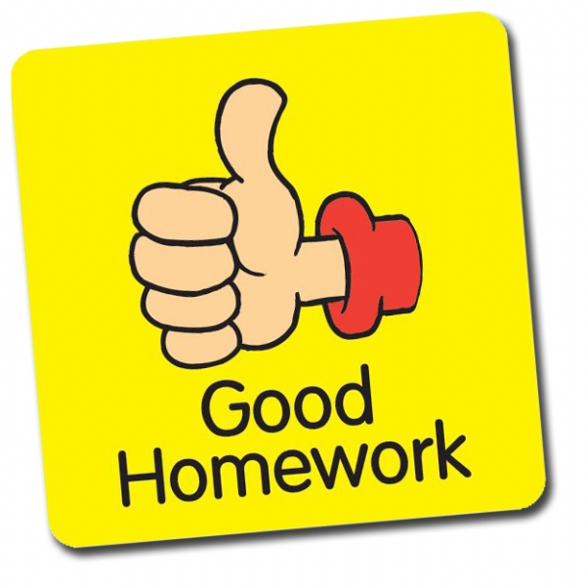
Reading
Please read with your child regularly (10-15 minutes most days if possible). When you hear your child read, please write the date on the left-hand side and add comments, using the following system to record each session:
✓✓ : my child read the book independently, with little or no help.
✓✓ : my child could read some of the words but needed help to maintain pace and flow.
✓ : this book was too difficult for my child to read alone, but I read it to my child and we shared and discussed it.

Spellings are given out on a Friday in the red ‘Spellings’ book and tested the following Friday morning. Please set aside a little time to learn spellings and work on patterns every week.

Homework Each half term an Enquiry related homework task will be set via email and on the class page of the school website. There will also be suggestions for fun online learning in key subject areas on there.
WATER: Please bring a named plastic drinking bottle each day.
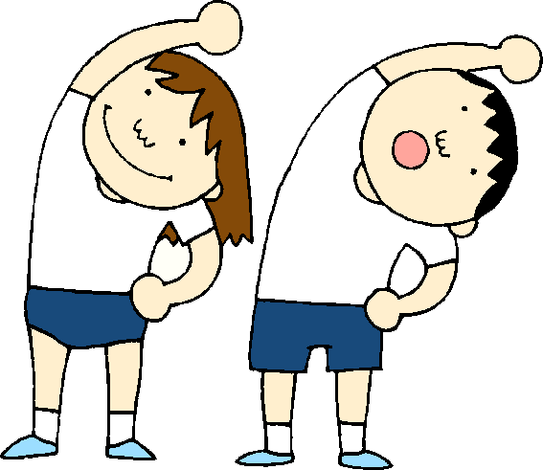P.E. kit should be worn on Mondays & Wednesdays.
Finally, please make sure that all school uniform is NAMED!

THANK YOU. Mrs Smith and Mrs Clark

Spring Term Learning

Coverage and Topics for the Spring Term

Subject | Spring Term 1st Half | Spring Term 2nd Half
English Writing | Coverage of Y1 and Y2 curriculum using the texts ‘Leo and the Octopus’, ‘Obsessive About Octopuses’ and ‘Tadpole’s Promise’. | Coverage of Y1 and Y2 curriculum using the texts ‘Tadpole’s Promise’, ‘The Odd Egg’ and non-fiction texts linked to our Humans and other Animals Enquiry.
English Guided Reading and Comprehension | Guided reading groups and comprehension activities in separate Year / Ability groups. | Guided reading groups and comprehension activities in separate Year / Ability groups.
Maths (to be taught in separate Year Groups) | Y1 Place Value, Addition & Subtraction.  Y2 Money and Multiplication & Division.  We will also have a daily Mastering Number session. | Y1 Length and Height & Mass and Volume.  Y2 Length & Height and Mass, Capacity & Temperature  We will also have a daily Mastering Number session.
Science  (MAIN ENQUIRY) | Do animals and humans need the same things to stay happy and healthy? | Do animals and humans need the same things to stay happy and healthy?
RHSE | Keeping myself safe. | Rights and respect.
History | Changes to animal welfare. Pit ponies, hunting, factory farms. | Find out about historic people in medicine/sport. Animal welfare. Charles Darwin.
Geography | Where do animals live in the world?  Name and locate 7 continents and 5 oceans (where zoo animals /pets originate). | Use 4 compass directions and use / make simple maps in orienteering games.
Art / DT | ANIMALS and HUMANS  Drawing and sculpture. | D.T. Make a moving Skeleton, and create Healthy Food (a fruit kebab)
RE | What do Jewish people believe about God, creation, humanity and the natural world? How do Jewish people show their beliefs and how they belong? | Understanding Christianity: Why does Easter matter to Christians?
PE | Invasion games and Dance | Invasion games and Dance
Music | Charanga music program, Pulse and Beat. | Enquiry related music: Carnival of the Animals, Peter and the Wolf
Computing | Purple Mash: Lego Builders and Maze Explorers | Purple Mash: Animated story books.

