**Enquiry Homework: Prepare a healthy meal/dish/snack**

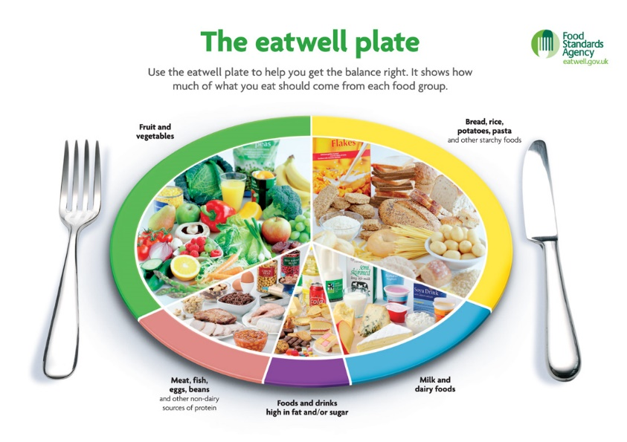

As part of our enquiry topic, we have been learning about how a healthy diet can help our hearts and circulatory system. It is important to have a balanced diet, using the “eatwell plate” as a guide to ensure both the balance and the proportion of food types we consume.

At home, we would like you to design and create a healthy meal or dish or snack.

Some ideas of what you could make:

* A healthy meal e.g. Spaghetti Bolognese
* A salad or pasta salad
* A fruit salad or a dessert
* A fruit smoothie
* A breakfast dish e.g. poached eggs on toast
* A homemade pizza

We would like you to take photos of your finished dish and explain why it is healthy. You could include an ingredients list and a recipe. You could include photos of how you made your dish. **PLEASE DO NOT BRING YOUR DISHES INTO SCHOOL.**

We will compile our work into class books of healthy dishes and recipes which we can share with the other classes.

**HAND IN DATE: MONDAY 28TH APRIL (Or earlier – send them in as and when they are completed)**